Now to move goods in Rajasthan E Way has to be generated. Please note following:-
- For those goods which are covered under schedule I,II,III,IV V and VI
- Kindly note goods for value exceeding Rs. 50000/- as defined in Rule 138 of the Rajasthan Goods and Services Tax Rules, 2017
- kindly note for any purpose
- E Way bill is required When value exceeding fifty thousand rupees in relation to a supply; or for reasons other than supply; or due to inward supply from an unregistered person Rule 138.
- E Way bill is required irrespective of the value of the consignment where goods are sent by a principal located in one State or Union territory to a job worker located in any other State or Union territory Rule 138. Proviso 3rd
- E Way bill is required irrespective of the value of the consignment where handicraft goods are transported from one State or Union territory to another State or Union territory by a person who has been exempted from the requirement of obtaining registration under clauses (i) and (ii) of section 24. Rule 138. Proviso 4th
- Below mentioed 2 circulars are important.
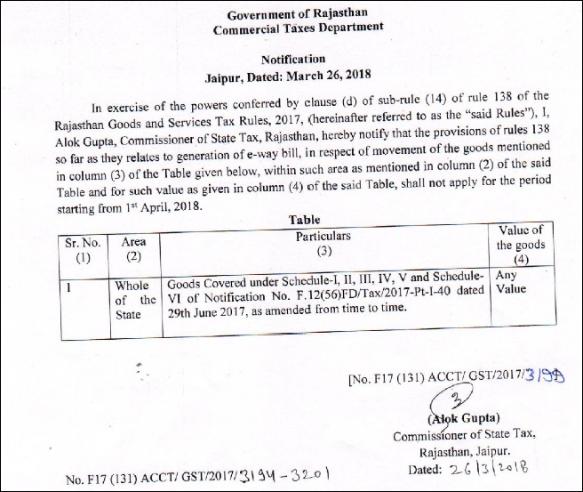
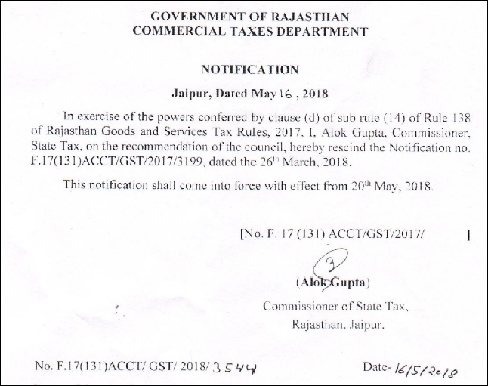

CHAPTER XVI
E-WAY RULES

138. Information to be furnished prior to commencement of movement of goods and generation of e-way bill.-

- Who shall furnish Part A of FORM GST EWB-01 before commencement of such movement
Type | in relation to a supply; or for reasons other than supply; or due to inward supply from an unregistered person | where goods are sent by a principal located in one State or Union territory to a job worker located in any other State or Union territory | handicraft goods are transported from one State or Union territory to another State or Union territory by a person who has been exempted from the requirement of obtaining registration under clauses (i) and (ii) of section 24
Value of Goods | When value exceeding fifty thousand rupees | Irrespective of the value of the consignment. | Irrespective of the value of the consignment.
e-way bill shall be generated by | - Every registered person who causes movement of goods of consignment  - transporter, on an authorization received from the registered person  - In the case of e-commerce- e-commerce operator or courier agency | the principal or the job worker, if registered, irrespective of the value of the consignment | the said person

- Who shall furnish Part A of FORM GST EWB-01 before commencement of such movement

(1) Every registered person who causes movement of goods of consignment value exceeding fifty thousand rupees—
(i) in relation to a supply; or
(ii) for reasons other than supply; or
(iii) due to inward supply from an unregistered person,
shall, before commencement of such movement, furnish information relating to the said goods as specified in Part A of FORM GST EWB-01, electronically, on the common portal along with such other information as may be required on the common portal and a unique number will be generated on the said portal:
Provided that the transporter, on an authorization received from the registered person, may furnish information in Part A of FORM GST EWB-01, electronically, on the common portal along with such other information as may be required on the common portal and a unique number will be generated on the said portal:
Provided further that where the goods to be transported are supplied through an e-commerce operator or a courier agency, on an authorization received from the consignor, the information in Part A of FORM GST EWB-01 may be furnished by such e-commerce operator or courier agency and a unique number will be generated on the said portal:

Provided also that where goods are sent by a principal located in one State or Union territory to a job worker located in any other State or Union territory, the e-way bill shall be generated either by the principal or the job worker, if registered, irrespective of the value of the consignment:

Provided also that where handicraft goods are transported from one State or Union territory to another State or Union territory by a person who has been exempted from the requirement of obtaining registration under clauses (i) and (ii) of section 24, the e-way bill shall be generated by the said person irrespective of the value of the consignment.

Explanation 1.– For the purposes of this rule, the expression ―handicraft goods‖ has the meaning as assigned to it in the Government of India, Ministry of Finance, notification No. 32/2017-Central Tax dated the 15th September, 2017 published in the Gazette of India, Extraordinary, Part II, Section 3, Sub-section (i), vide number G.S.R 1158 (E) dated the 15th September, 2017 as amended from time to time.
Explanation 2.- For the purposes of this rule, the consignment value of goods shall be the value, determined in accordance with the provisions of section 15, declared in an invoice, a bill of supply or a delivery challan, as the case may be, issued in respect of the said consignment and also includes the central tax, State or Union territory tax, integrated tax and cess charged, if any, in the document and shall exclude the value of exempt supply of goods where the invoice is issued in respect of both exempt and taxable supply of goods.
(2) Where the goods are transported by the registered person as a consignor or the recipient of supply as the consignee, whether in his own conveyance or a hired one or a public conveyance, by road, the said person shall generate the e-way bill in FORM GST EWB-01 electronically on the common portal after furnishing information in Part B of FORM GST EWB-01.
(2A) Where the goods are transported by railways or by air or vessel, the e-way bill shall be generated by the registered person, being the supplier or the recipient, who shall, either before or after the commencement of movement, furnish, on the common portal, the information in Part B of FORM GST EWB-01:
Provided that where the goods are transported by railways, the railways shall not deliver the goods unless the e-way bill required under these rules is produced at the time of delivery.
(3) Where the e-way bill is not generated under sub-rule (2) and the goods are handed over to a transporter for transportation by road, the registered person shall furnish the information relating to the transporter on the common portal and the e-way bill shall be generated by the transporter on the said portal on the basis of the information furnished by the registered person in Part A of FORM GST EWB-01:
Provided that the registered person or, the transporter may, at his option, generate and carry the e-way bill even if the value of the consignment is less than fifty thousand rupees:
Provided further that where the movement is caused by an unregistered person either in his own conveyance or a hired one or through a transporter, he or the transporter may, at their option, generate the e-way bill in FORM GST EWB-01 on the common portal in the manner specified in this rule:
Provided also that where the goods are transported for a distance of upto fifty kilometers within the State or Union territory from the place of business of the consignor to the place of business of the transporter for further transportation, the supplier or the recipient, or as the case may be, the transporter may not furnish the details of conveyance in Part B of FORM GST EWB-01.
Explanation 1.– For the purposes of this sub-rule, where the goods are supplied by an unregistered supplier to a recipient who is registered, the movement shall be said to be caused by such recipient if the recipient is known at the time of commencement of the movement of goods.
Explanation 2.- The e-way bill shall not be valid for movement of goods by road unless the information in Part-B of FORM GST EWB-01 has been furnished except in the case of movements covered under the third proviso to sub-rule (3) and the proviso to sub-rule (5).
(4) Upon generation of the e-way bill on the common portal, a unique e-way bill number (EBN) shall be made available to the supplier, the recipient and the transporter on the common portal.
(5) Where the goods are transferred from one conveyance to another, the consignor or the recipient, who has provided information in Part A of the FORM GST EWB-01, or the transporter shall, before such transfer and further movement of goods, update the details of conveyance in the e-way bill on the common portal in Part B of FORM GST EWB-01:
Provided that where the goods are transported for a distance of upto fifty kilometers within the State or Union territory from the place of business of the transporter finally to the place of business of the consignee, the details of the conveyance may not be updated in the e-way bill.
(5A) The consignor or the recipient, who has furnished the information in Part A of FORM GST EWB-01, or the transporter, may assign the e-way bill number to another registered or enrolled transporter for updating the information in Part B of FORM GST EWB-01 for further movement of the consignment:
Provided that after the details of the conveyance have been updated by the transporter in Part B of FORM GST EWB-01, the consignor or recipient, as the case may be, who has furnished the information in Part A of FORM GST EWB-01 shall not be allowed to assign the e-way bill number to another transporter.
(6) After e-way bill has been generated in accordance with the provisions of sub-rule (1), where multiple consignments are intended to be transported in one conveyance, the transporter may indicate the serial number of e-way bills generated in respect of each such consignment electronically on the common portal and a consolidated e-way bill in FORM GST EWB-02 maybe generated by him on the said common portal prior to the movement of goods.
(7) Where the consignor or the consignee has not generated the e-way bill in FORM GST EWB-01 and the aggregate of the consignment value of goods carried in the conveyance is more than fifty thousand rupees, the transporter, except in case of transportation of goods by railways, air and vessel, shall, in respect of inter-State supply, generate the e-way bill in FORM GST EWB-01 on the basis of invoice or bill of supply or delivery challan, as the case may be, and may also generate a consolidated e-way bill in FORM GST EWB-02 on the common portal prior to the movement of goods:
Provided that where the goods to be transported are supplied through an e-commerce operator or a courier agency, the information in Part A of FORM GST EWB-01 may be furnished by such e-commerce operator or courier agency.
(8) The information furnished in Part A of FORM GST EWB-01 shall be made available to the registered supplier on the common portal who may utilize the same for furnishing the details in FORM GSTR-1:
Provided that when the information has been furnished by an unregistered supplier or an unregistered recipient in FORM GST EWB-01, he shall be informed electronically, if the mobile number or the e-mail is available.
(9) Where an e-way bill has been generated under this rule, but goods are either not transported or are not transported as per the details furnished in the e-way bill, the e-way bill may be cancelled electronically on the common portal within twenty four hours of generation of the e-way bill:
Provided that an e-way bill cannot be cancelled if it has been verified in transit in accordance with the provisions of rule 138B.

Provided further that the unique number generated under sub-rule (1) shall be valid for a period of fifteen days for updation of Part B of FORM GST EWB-01.
(10) An e-way bill or a consolidated e-way bill generated under this rule shall be valid for the period as mentioned in column (3) of the Table below from the relevant date, for the distance, within the country, the goods have to be transported, as mentioned in column (2) of the said Table:- Sl. No. | Distance | Validity period
(1) | (2) | (3)
1. | Upto 100 km. | One day in cases other than Over Dimensional Cargo
2. | For every 100 km. or part thereof thereafter | One additional day in cases other than Over Dimensional Cargo
3. | Upto 20 km | One day in case of Over Dimensional Cargo
4. | For every 20 km. or part thereof thereafter | One additional day in case of Over Dimensional Cargo:

